# Lab2

## Name: Zeng Yuhang

## ID: 222320008

1. Building a network topology

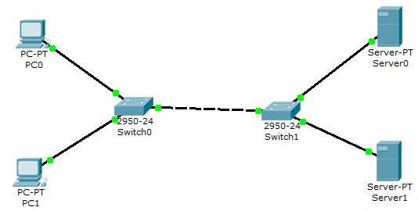

Meanwhile, configure network devices according to the specified parameters.

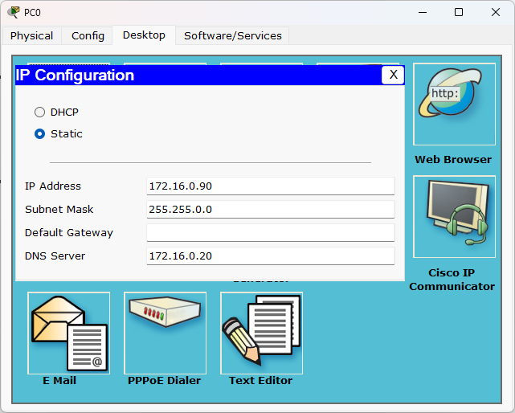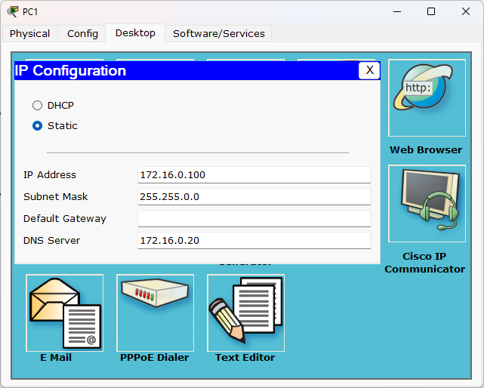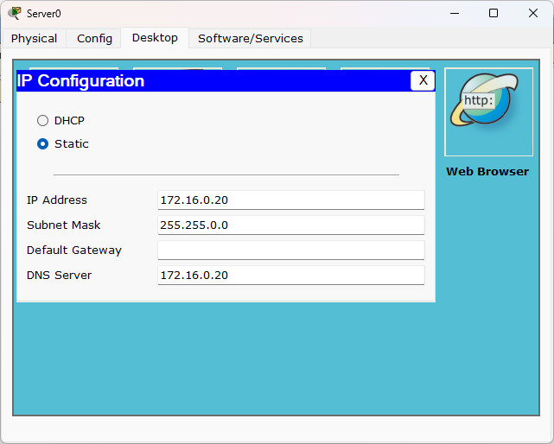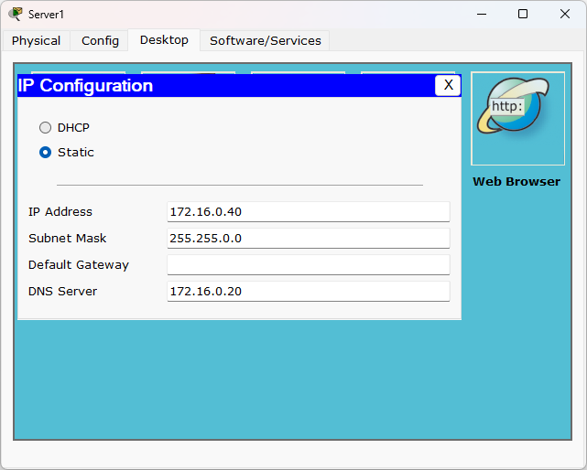

1. Setting up the mail server

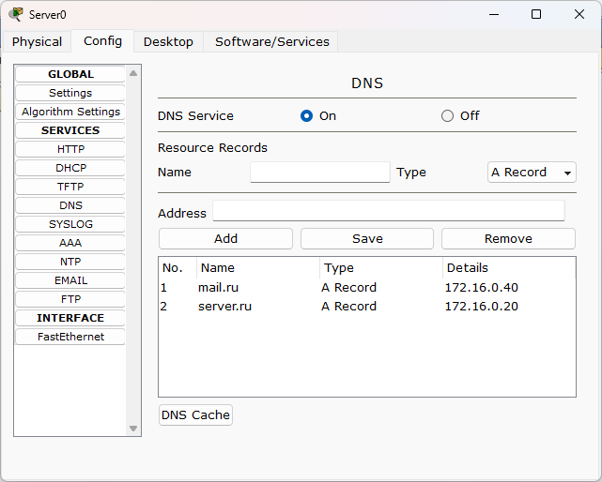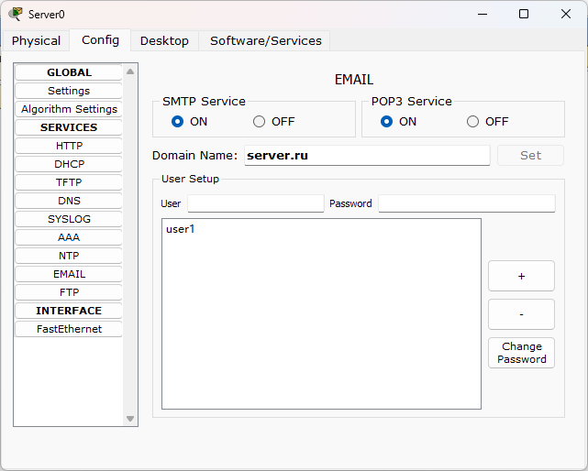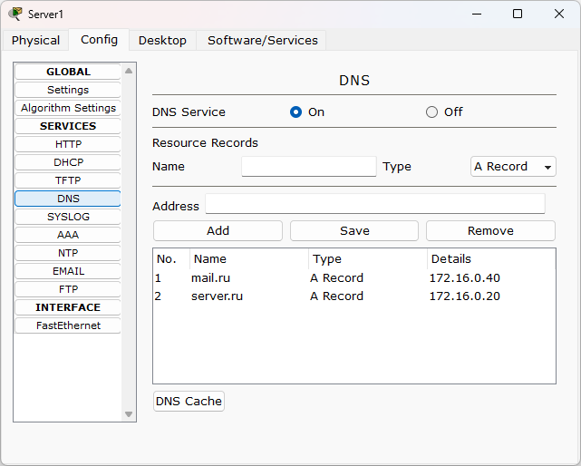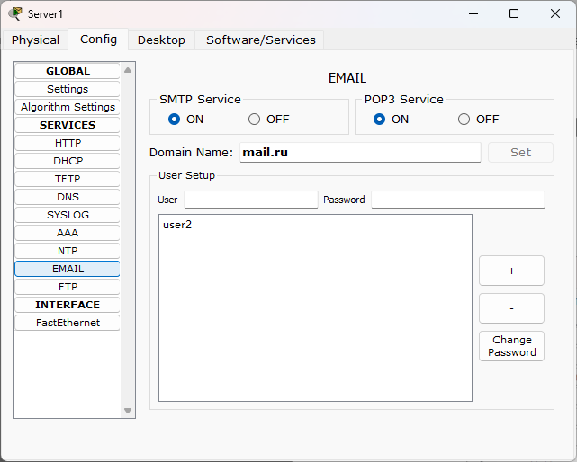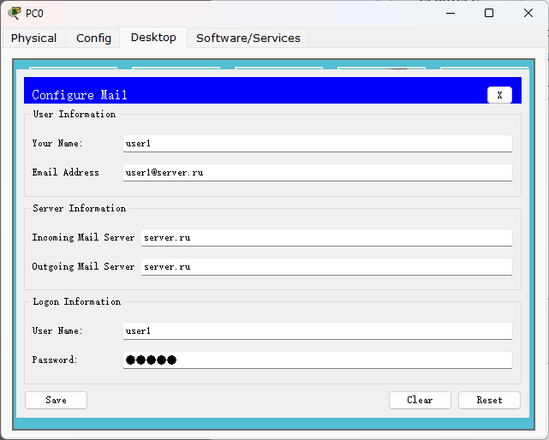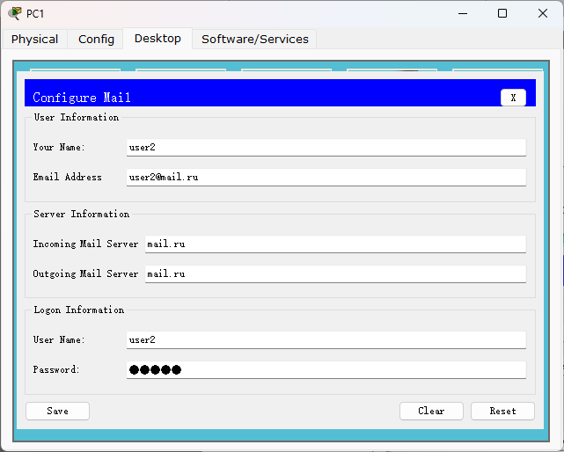

1. Research of applied mail protocols in simulation mode

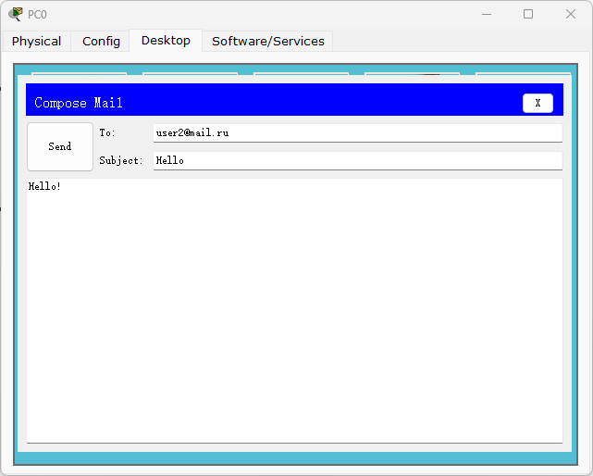

We need to press “Send” button to send the letter. And the node will produce a SMTP package. The message is sending from 172.16.90:1031 to 172.16.20:25 with the contents of the mail. And the server will response the SMTP package back to PC0.

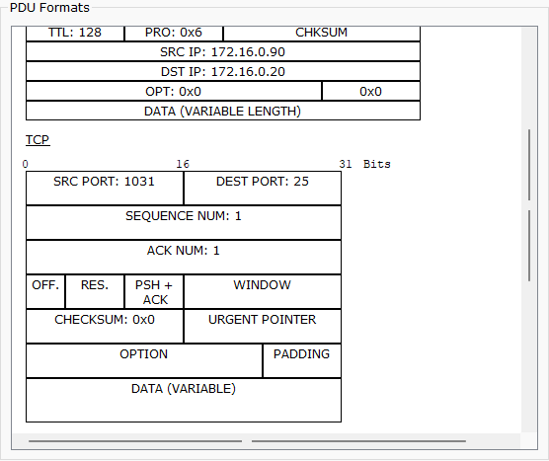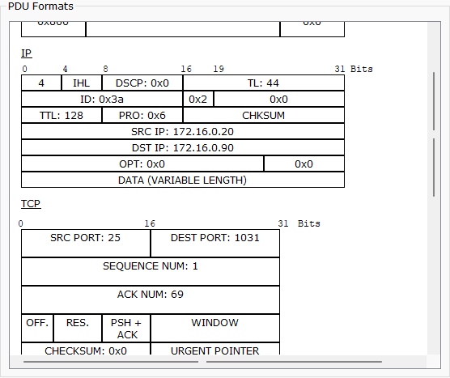

Sever0 accesses the DNS server for mail.ru and sends the mail from 1031 port of itself to the port 25 of specified server. And the specified server will also send a response back to server0.

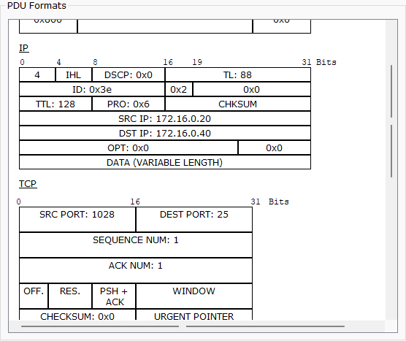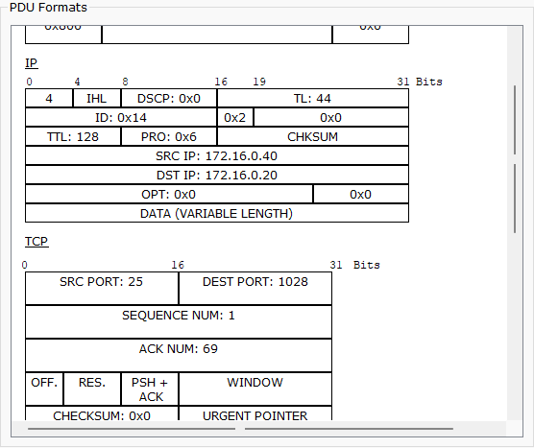

Until now, the mail has successfully sent to the destination server. However, if the PC1 wants to receive the mail, it has to send POP3 package to its own mail server to pull the mail store in it. The POP3 package returned by server will contain all the mail sending to PC1. The ports for this are 1028 on PC1 and 110 on server.

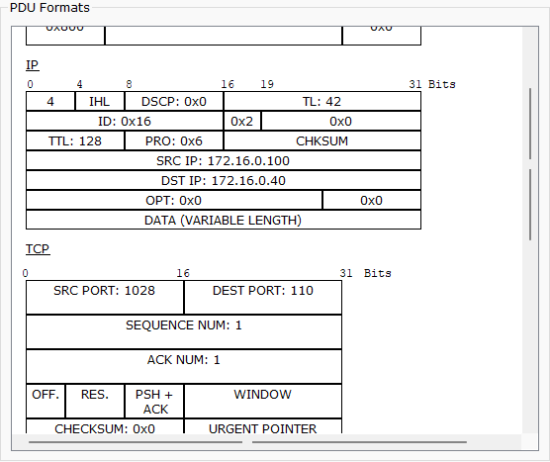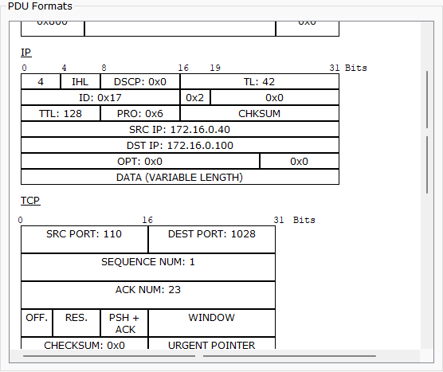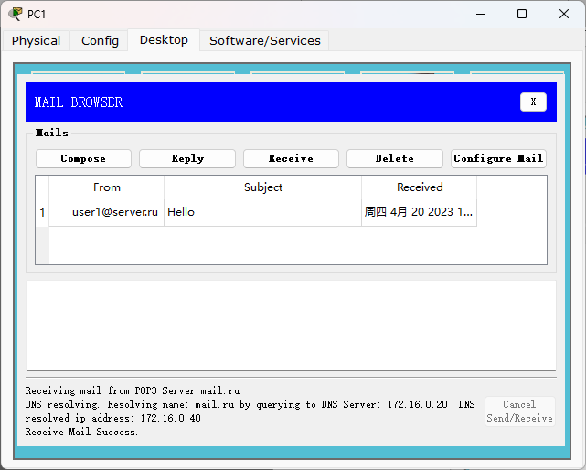

1. Conclusion

* routes of the passages

The mail will be sent to the server of server.ru in SMTP package. After response to the source device of the mail, the server uses DNS to find the destination server of mail.ru and sends to it. The destination server also needs to response the server of server.ru. Until this, the mail sending has done. Then, the destination device of the mail sends POP3 package to pull the mails from the server of mail.ru. The server response with mails sent to the device in POP3 package. Finally, the mail is received successfully.

* contents

SMTP: 172.16.0.90:1031 <-> 172.16.0.20:25

SMTP: 172.16.0.20:1031 <-> 172.16.0.40:25

POP3: 172.16.0.100:1028 <-> 172.16.0.40:100

* explanation of the results obtained

SMTP packages will send the mails to the server of the destination of the mails. The users can only receive the mails after POP3 packages pull the mails from the server of its own mail server.